2008 GISMO ON-Sky Test Plan v.1.1

J.G. Staguhn & D.J. Benford

This document describes our proposed approach to integrate the GISMO instrument on the telescope and to characterize its performance by means of astronomical observations. In the first part we describe the required tests and how we plan to approach them at the telescope. In the second part of the document we present a brief first cut observing plan, which will be adjusted in near-real-time to the conditions we encounter when using GISMO at the 30m. The procedures required to set up and test the instrument and the integration/synchronization of the telescope with the bolometer data are presumed to have been completed by the efforts of the 2007 observing run and recent work.

1. Procedures to verify instrument alignment and performance
- Once GISMO is installed in the receiver room, a first alignment will be done without the need to look at the sky (i.e. during heterodyne optical setup):
  - Laser alignment for the two GISMO mirrors, checking optical path through to IRAM mirror M4 (laser has to hit correct positions of mirrors).
  - (Eccosorb-) cold load mapping of GISMO beam through M4, verifying proper illumination of the mirrors and quantifying any vignetting.
  - Magnetic field pickup as a function of telescope position can be measured for later use in data analysis.
- Once M4 is set to bolometer position GISMO alignment will be made by:
  - Using IRAM bidirectional Laser system together with our laser to refine the geometrical instrument alignment
  - finding the center and mapping of the GISMO beam by displacing an absorber in front of the beam at the vertex tube level
  - If necessary, the beam from GISMO will be verified using the small chopper on the lifting platform that gives access to the subreflector.
After several iterations of 2, the GISMO optics should be near being aligned for optimal illumination of the secondary. Using the same positions as 2007 will likely result in sufficiently performing illumination to enable observations within a few hours of startup.
- Conduct long integrations with shutter closed to determine noise beackground.
- Optimize bolometer bias and SQUID tuning for the observed background conditions. Conduct gain/offset calibrations using the shutter/illuminator system.
- Determine pointing and focus by observing bright sources. If necessary, this can be done on the limb of the moon, but compact sources such as Saturn (available ~6h-12h UTC), 3C345 (available 10h-20h UTC), 3C454.3 (available 17h-2h UTC), and 3C84 (available 21h-7h UTC) are strongly preferred as the realtime display signal will be obvious. Fainter solar system objects such as Uranus and Neptune and minor planets Ceres and Vesta will also be considered.
Note: at this point it might turn out to be required to go back to 2, since it might be that some mirrors need to be repositioned. However, prior experience has shown that pointing and focus are similar to the values used for MAMBO.
- Perform a skydip in order to tie measured gain parameters to sky brightness for the bolometers.
- Observe strong point-like sources, in particular those from the Mambo calibrator list and our own list of nonthermal sources (Appendices B and C). verify beam shape and beam size (verify that beam asymetry, i.e. 21"x15", observed in 2007 observing run. This test will also be used to refine the pointing and focus settings and refine our calibration. These observations, by comparing them to observations described in 3, will also help to determine main beam efficiencies.
- Verify the plate scale, pixel mapping, and array position angle by introducing alt-az offsets and locating the source in the resulting maps and by pointing on a bright source over a large elevation range.
- Measure the rotation center of the detector array. Sources transiting close to the zenith (such as 3C84 (RA 3h, Dec +41)) will be used so as to maximize the parallactic angle rate. Due to the required length of tracking these sources, this will also provide information on how the noise integrates down on bright sources. Note: there is an 83 deg elevation limit.
- We will begin regular observations with bright sources (>10Jy) in Lissajous mode and work down in half-decade steps to >10mJy sources,. The critical aspects to be tested are the radiometric integration down of noise and the consistency of measured flux with expected flux. Appendix D lists our preliminary catalog of sources to be used for this element.
- We next proceed to integrate for a long time on bright (>10mJy) scientifically interesting sources, using point-like, compact, and then extended sources in order to verify instrument performance. The order of observations in 11-14 will be arranged according to object availability and system performance. Appendices E and F list some of these sources.
- We will observe strong, extended Galactic sources [insert sources here]. These observations will help to test the data reduction capabilities with different observing strategies (see also summary of pako scripts for a variety observing modes, Appendix A).
- We next extend these observations to sources with lower, but still strong fluxes (hundreds of milli-Jy) that will produce scientifically relevant results. Such sources include in particular SN remnants, IR dark clouds, and a variety of stars. These measurements will again help improve observing strategies for most accurate data reduction.
- Start targeted observations of point-like luminous galaxies and quasars with strong fluxes (several tens to a few mJy). These observations will reveal our capabilities to extract weaker point sources from longer (tens of minutes to a few hours) observations. We have a large number of source candidates for this that are available around the clock which are scientifically interesting to observe at 2mm.
- We will observe a few resolved extragalactic sources (e.g. NGC660, NGC891). This will provide interesting science and help understand issues related to extracting extended sources from long integration data. Scientifically, these observations will be used to validate or refute the Dwek, Galliano, and Chanial model of Hii regions and star formation-driven thermal dust emission.
- We will conduct targeted observations of extremely highly luminous and/or redshifted sources (starting with the brightest ones such as Arp220, PSS_J2322+1944, etc.) to extend our understanding of our data reduction capabilities for extracting sources from data with long integrations.
- If we should get here: Observe selected fields in Deep Survey areas (GOODS-N, COSMOS, SHADES, etc.) by making sure a number of scientifically very interesting sources will be covered.

2. Preliminary schedule outline for GISMO run 2008
Day 0: 1
Day 1: 2, 3, 4, 5, 6, 7, 8
Day 2: 3, 4, 5, 6, 7, 8, 9
Day 3: 6, 9, 10
Day 4: 9, 10, 11, 12, 13, 14
Day 5: 10, 11, 12, 13, 14
Day 6: 10, 11, 12, 13, 14
Day 7: 10, 11, 12, 13, 14, 15, 16
Day 8: 15, 16

Appendix A: Pako scripts available for GISMO observations

Note: Haven’t looked over this yet! Still 2007 version!

1) gismo_observer.pako - to set some very general parameters at the start
2) gismo_setup.pako - to select the RECIEVER, BACKEND combination for GISMO
3) gismo_pointing.pako - to do a pointing check
4) gismo_focus.pako - to do a focus check
5) gismo_tip.pako - to do a tip (skydip) measurement
6a) gismo_onoff.pako - to do a single ONFOFF/SWWOBBLER observation
6b) gismo_otfmap_az.pako - to do a single OTFMAP/SWWOBBLER observation, scanning in azimuth (rows)
6c) gismo_otfmap_el.pako - to do a single OTFMAP/SWWOBBLER observation, scanning in elevation (columns)

Appendix B: Selected calibration/pointing sources

These sources were selected on the basis of availability and 2mm flux greater than 1Jy, which should yield a S/N of >100 in <1 min in any usable observing conditions. Some solar system objects (minor planets) have lower fluxes, but are included for completeness because the flux accuracy can be fairly high.

The fluxes reflect our best 2 mm estimates; planet fluxes are not precisely calculated.

HB0235+164 02:38:38.9 16:36:59 ! 1.5 Jy
3C84_(NGC1275) 03:19:48.1601 +41:30:42.103 ! 5 Jy
HB0735+178 07:38:07.4 17:42:19 ! 2 Jy
HB0736+017 07:39:18.0 01:37:05 ! 1.5 Jy
HB0851+202 08:54:48.9 20:06:31 ! 2 Jy
HB0923+392 09:27:03.0 39:02:21 ! 3 Jy
HB1055+018 10:58:29.6 01:33:59 ! 2.5 Jy
HB1308_326 13:10:28.6 32:20:44 ! 1.5 Jy
3C345 16:42:58.8 39:48:37 ! ~4 Jy
HB1741-038 17:43:58.8 -03:50:05 ! 2 Jy
HB1749+096 17:51:32.8 09:39:01 ! 2 Jy
HB1823+568 18:24:07.1 56:51:01 ! 1.5 Jy
HB2145+067 21:48:05.4 06:57:39 ! 2.5 Jy
BL_Lac 22:02:43.3 42:16:40 ! 2 Jy
3C446 22:25:47.2 -04:57:01 ! 2 Jy
3C454.3 22:53:57.75 +16:08:53.6 ! ~15 Jy
Ceres 09:57:13.87 19:31:08.8 ! 0.4 Jy
Juno 17:43:30.50 -12:42:55.7 ! 0.02 Jy
Vesta 02:41:06.06 04:15:58.7 ! 0.4 Jy
Saturn 11:16:00 06:38:24 ! ~270 Jy; 16’’
Uranus 23:21:33 -05:00:24 ! 8 Jy; 3.65’’
Neptune 21:35:33 -14:42:24 ! 3 Jy; 2.30’’

Appendix C: Availability of selected calibration sources

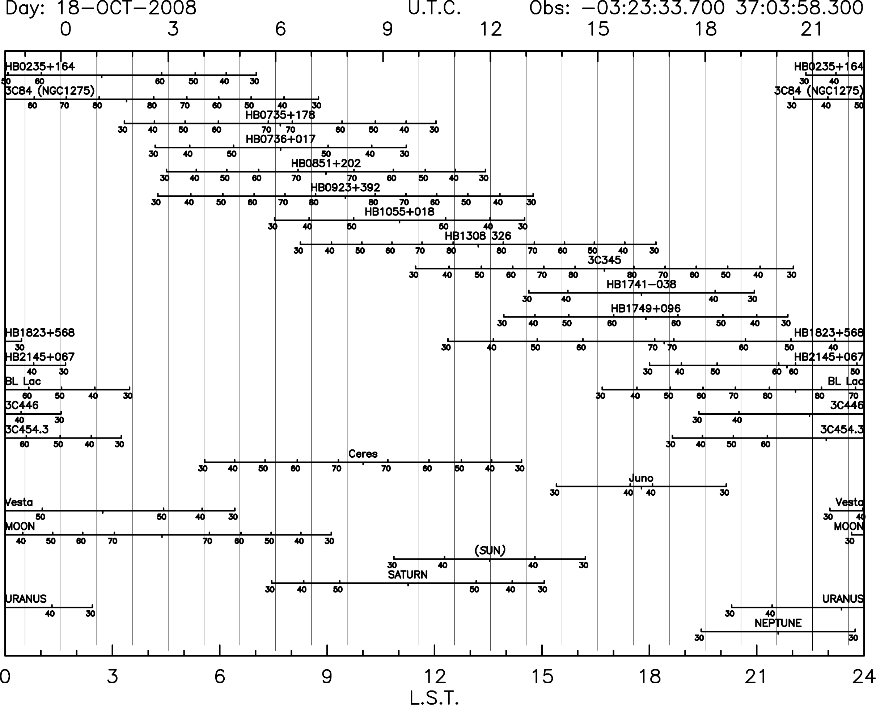

Appendix D: Selected integration test sources

These sources were selected to represent targets to be used in testing instrument performance while integrating down to successively fainter flux limits. This list is organized in four subsections by flux, at levels of >1Jy, >0.3Jy, >0.1Jy, >0.03Jy.

The fluxes reflect our best 2 mm estimates; planet fluxes are not precisely calculated.

Object Name RA, Dec (J2000.0) Type/Velocity/Redshift Flux 2mm
HB 0235+164 02h38m38.9s +16d36m59s QSO >30000 0.9400 1.5Jy
NGC 1275 03h19m48.1s +41d30m42s G 5264 0.0176 30Jy
HB 0735+178 07h38m07.4s +17d42m19s QSO >30000 0.4240 2Jy
HB 0736+017 07h39m18.0s +01d37m05s QSO >30000 0.1910 1.5Jy
OJ +287 08h54m48.9s +20d06m31s QSO >30000 0.3060 2Jy
HB 0923+392 09h27m03.0s +39d02m21s QSO >30000 0.6953 3Jy
HB 1055+018 10h58m29.6s +01d33m59s QSO >30000 0.8900 2.5Jy
3C 273 12h29m06.7s +02d03m09s QSO >30000 0.1583 15Jy
3C 279 12h56m11.1s -05d47m22s QSO >30000 0.5362 10Jy
HB 1308+326 13h10m28.6s +32d20m44s QSO >30000 0.9960 1.5Jy
3C 345 16h42m58.8s +39d48m37s QSO >30000 0.5928 ~4Jy
HB 1741-038 17h43m58.8s -03d50m05s QSO >30000 1.0540 2Jy
HB 1749+096 17h51m32.8s +09d39m01s QSO >30000 0.3220 2Jy
HB 1823+568 18h24m07.1s +56d51m01s QSO >30000 0.6640 1.5Jy
HB 2145+067 21h48m05.4s +06d57m39s QSO >30000 0.9900 2.5Jy
BL Lac 22h02m43.3s +42d16m40s QSO 20566 0.0686 2Jy
3C 446 22h25m47.2s -04d57m01s QSO >30000 1.4040 2Jy
3C 454.3 22h53m57.7s +16d08m54s QSO >30000 0.8590 7Jy

HB 0906+015 09h09m10.1s +01d21m36s QSO >30000 1.0244 0.7Jy
3C 216 09h09m33.5s +42d53m46s QSO >30000 0.6703 0.5Jy
HB 0954+556 09h57m38.2s +55d22m58s QSO >30000 0.8955 0.5Jy
MRK 0421 11h04m27.3s +38d12m32s G 9000 0.0300 0.5Jy
FBQS J115019.2+241753 11h50m19.2s +24d17m54s QSO >30000 0.2000 0.5Jy
W Com 12h21m31.7s +28d13m59s QSO >30000 0.1020 1.0Jy
HB 1532+016 15h34m52.4s +01d31m04s QSO >30000 1.4350 0.5Jy
HB 1538+149 15h40m49.5s +14d47m46s QSO >30000 0.6050 0.4Jy
MRK 0501 16h53m52.2s +39d45m37s G 10092 0.0337 0.4Jy
HB 1749+701 17h48m32.8s +70d05m51s QSO >30000 0.7700 0.4Jy
UGC 11130 18h06m50.7s +69d49m28s G 15289 0.0510 1.0Jy

Object Name RA, Dec (J2000.0) Type/Velocity/Redshift Flux 2mm
FBQS J0006-0004 00h06m22.6s -00d04m25s QSO >30000 1.0370 0.1Jy
3C 043 01h29m59.8s +23d38m20s QSO >30000 1.4590 0.1Jy
3C 048 01h37m41.3s +33d09m35s QSO >30000 0.3670 0.15Jy
3C 119 04h32m36.5s +41d38m28s G >30000 1.0230 0.1Jy
HB 0615+820 06h26m03.0s +82d02m26s QSO >30000 0.7100 0.25Jy
3C 161 06h27m10.1s -05d53m05s RadioS ... . 0.13Jy
FBQS J074110.6+311200 07h41m10.7s +31d12m00s QSO >30000 0.6314 0.16Jy
4C +22.21 08h23m24.7s +22d23m03s QSO >30000 0.9510 0.3Jy
HB 1237-101 12h39m43.0s -10d23m29s QSO >30000 0.7520 0.16Jy
4C +32.44 13h26m16.5s +31d54m10s G >30000 0.3700 0.16Jy
HB 1351-018 13h54m06.9s -02d06m03s QSO >30000 3.7070 0.11Jy
HB 1508-055 15h10m53.6s -05d43m07s QSO >30000 1.1850 0.25Jy
PKS 1543+005 15h46m09.5s +00d26m25s G >30000 0.5500 0.13Jy
MG2 J185027+2825 18h50m27.6s +28d25m13s QSO >30000 2.5600 0.10Jy
HB 2126-158 21h29m12.2s -15d38m41s QSO >30000 3.2680 0.16Jy

PKS 0531+19 05h34m44.5s +19d27m22s G ... . 0.06Jy
4C -06.18 07h44m21.6s -06d29m36s RadioS ... . 0.03Jy
UGC 05101 09h35m51.6s +61d21m11s G 11802 0.0394 0.03Jy
UGC 08058 12h56m14.2s +56d52m25s G 12642 0.0421 0.03Jy
MRK 0273 13h44m42.1s +55d53m13s G 11326 0.0378 0.03Jy
3C 298 14h19m08.2s +06d28m35s QSO >30000 1.4373 0.03Jy
3C 303.1 14h43m14.8s +77d07m29s G >30000 0.2670 0.03Jy
HB 1524-136 15h26m59.4s -13d51m00s QSO >30000 1.6870 0.08Jy
PKS 1607+26 16h09m13.3s +26d41m29s G >30000 0.4730 0.03Jy
PKS 2127+04 21h30m32.9s +05d02m17s G >30000 0.9900 0.08Jy

Appendix E: Selected Science Sources

These sources were selected to represent bright (≥10 mJy) targets to be used for early science results.

Cygnus_A 19:59:28.3 40:44:02 ! ~1Jy total, extended
HB0716+714 08:21:53.4 71:20:36 ! BL Lac-type, 4 Jy?; variability
MonR2IRS2 06:05:20.00 -06:22:39.70 ! peak ~0.5Jy, 0.01Jy depth
DR21 ! 360mJy/beam @ 2mm
NGC660 01:43:02.4 13:38:43 ! Cold Dust
NGC891 02:22:33.4 42:20:57 ! Cold Dust
Arp220 15:34:57.1 23:30:11 ! ULIRG ~0.01 Jy
IIZw40 05:55:42.6 03:23:32 ! Dwek ~0.02 Jy
IC342 03:46:48.5 68:05:46 ! Dwek 0.01 – 0.06 Jy
NGC1068 02:42:40.7 00:00:48 ! Dwek right at turnover syncr./dust
NGC6240 16:52:58.9 02:24:03 ! Dwek ~ 0.01 Jy
Orion-IRC2 05:32:47.00 -05:24:24.00 ! extend to North?
APM08279+5254 08:31:41.59 52:45:17.0 ! J2000; 10mJy?
IRDC_43 18:53:18.5 01:25:4.6 ! required rms 2mJy
IRDC 30 18:44:19.1 -04 00 2.6 ! required rms 2mJy
! SN Remnants
Tycho 00:25:18 +64:09:00 ! FLUX 2.63 0.61 ! diam = 8'
3C58 02:05:41 +64:49:00 ! FLUX 20.0 0.10 ! diam = 9x5'
Crab 05:34:31 +22:01:00 ! FLUX 231. 0.30 ! diam = 7x5' peak=8mJy/asec2
Kepler 17:30:42 -21:29:00 LSR 0.0 FLUX 0.77 0.64 ! diam = 3' peak=
Cas_A 23:23:26 +58:48:00 LSR 0.0 FLUX 69.9 0.77 ! diam = 5' peak=0.11K

Appendix F: Selected Weak Science Sources

M104(Sombrero) 12:39:59.4 -11:37:23 ! 0.0034 Jy
IC5146 (cold filament with embedded presetallar cores): 8mJy/beam
IRAS F10214+4724 10:24:34.54 +47:09:09.8 ! z=2.2855 F1.2=24mJy? 850=50mJy
APM 08279+5255 08:31:41.64 +52:45:17.5 !RQQ z=3.9 F1.2=20mJy 850=80
Cloverleaf 14:15:46.23 +11:29:44.0 ! z= 2.558 F1.2=18mJy 850=52
PSS J2322+1944 23:22:07.25 +19:44:22.08 ! z=4.1192 F1.2=9.6mJy 850=22.5
BR 1202-0725 12:05:22.98 -07:42:29.9 ! z=4.69 F1.2=12.6mJy 850=42
PSS1418+4449 14:18:31.7 +44:49:37.6 ! z=4.32 F1.2=6.3mJy 850=10.4
SDSS J1148+5251 11:48:16.64 +52:51:50.3 ! z=6.418 F1.2=5.0mJy

Appendix F: Availability of selected astronomical sources
The following plot shows the availability of selected sources. This plot is meant to illustrate the completeness of coverage of sources throughout the day, and is by no means a complete list of GISMO sources.

