T16-07 GISMO ON-Sky Testplan v.2

J. Staguhn, D. Benford & Rick Arendt

The following document describes our approach on how to align the GISMO instrument on the telescope and how to characterize its performance by means of astronomical observations. In the first part we describe the required tests and how we plan to approach them at the telescope. In the second part of the document we present a brief first cut observing plan, which will obviously be required to be adjust to the progress we will actually make when using GISMO at the 30m. The procedures required to setup/test the detector/readout system and the integration/synchronization of the telescope with the bolometer data will have been completed by the time of the first on-sky observations and are described elsewhere (“GISMO setup.doc”, “Stage 1 GISMO Alignment.doc.”)

1. Procedures to verify instrument alignment and performance
0. Measurement with cryostat window blanked-off to know the instrumental noise (added by S.Leclercq and K.Schuster October 2, 2008 ; was not in original plan but we think it is very important to conduct this step).
- Once GISMO is installed in the receiver room, a first alignment will be done without the need to look at the sky (i.e. during heterodyne optical setup):
  - Laser alignment for the two GISMO mirrors, check optical path through to IRAM mirror M4 (laser has to hit correct positions of mirrors).
  - (Eccosorb-) cold load mapping of GISMO beam through M4
- Once M4 is set to bolometer position GISMO alignment will be made by:
  - Using IRAM bidirectional Laser system together with our laser to refine the geometrical instrument alignment
  - finding the center and mapping of the GISMO beam by displacing an absorber in front of the beam at the vertex tube level (Santiago told us that this is a standard method used at the 30m)
  - using Ernst Kreysa’s movable (undersized, which is good for us) rotating chopper on the lifting platform that gives access to the subreflector. This will provide an AC signal from the secondary to the bolometers. This setup will be more complicated, Santiago is working on getting this ready for us, thanks Santiago!
After several iterations of 2.c), the GISMO optics should be near being aligned for optimal illumination of the secondary.
- Determine pointing and focus by observing bright, extended sources. In particular this can be done efficiently on the edge of the moon (on Nov. 5 the Moon will be observable between 5h and 12h UTC), but Jupiter (12h to 15h UTC), Saturn (similar UTC as the Moon), and Mars (23h to 6h UTC) will be good sources, too. In the evening hours Uranus, which might be hard to find with a strongly defocused setup, will be available for this. Note: These tests can be done in realtime, since the sources will show up on our realtime display of the detector readout.
Note: at this point it might turn out to be required to go back to 2c), since it might be that some mirrors need to be repositioned. However, in terms of the focus position we will probably benefit from the fact that at 2 mm wavelength the focal depth of the “slow” IRAM optics is about 20cm.
- Perform a skydip in order to provide gain parameters for the bolometers.
- Observe strong point-like sources, in particular those from the Mambo calibrator list and our own list. This test will be used to refine the pointing and focus settings and refine our calibration. These observations, by comparing them to observations described in 3, will also help to determine main beam efficiencies.
- Test rotation/pointing vs. az/el. In particular sources at the time of crossing close to the zenith (such as 3C84 (RA 3h, Dec +41)) will be used for this. Due to the required length of tracking these sources will also provide information on how the noise integrates down. Our data analysis GUI provides helpful tools for these tests by allowing us to reduce the data with different reference pixels for rotational axis, on-source pixel position, and pixel angular spacing on sky.
- With the newly determined optical parameters (pointing offsets, rotational with respect to PA of array, pixel of rotational axis), we will integrate for a long time on other, fainter (and more scientifically interesting) near-point-like sources in order to verify that the data acquisition works (no smearing out of source over time, rotation on array). Again, analyze how noise integrates down and verify pointing offsets.
- Repeat standard pointing observations all over the sky.
- We will observe strong, extended Galactic sources such as Orion, W51, G34. These observations will help to test the data reduction capabilities with different observing strategies (see also summary of pako scripts for a variety observing modes, Appendix A).
- Extend galactic observations to more sources with lower, but still strong fluxes (hundreds of milli-Jy) that will produce scientifically relevant results. Such sources include in particular SN remnants, IR dark clouds, and if possible (due to low elevation) the Galactic center. These measurements will again help improve observing strategies for most accurate data reduction.
- Start targeted observations of point-like luminous galaxies and quasars with strong fluxes (several tens to a few mJy). These observations will reveal our capabilities to extract weaker point sources from longer (tens of minutes to a few hours) observations. We have a large number of source candidates for this that are available around the clock which are scientifically interesting to observe at 2mm.
- We will observe a few resolved extragalactic sources (e.g. Antennae galaxy). This will provide interesting science and help understand issues related to extracting extended sources from long integration data.
- We will conduct targeted observations of extremely highly luminous and/or redshifted sources (starting with the brightest ones such as Arp220, PSS_J2322+1944, etc.) to extend our understanding of our capabilities of extracting sources from data with long integrations.
- If we should get here: Observe selected fields in Deep Survey areas (GOODS-N, COSMOS, SHADES, etc.) by making sure a number of scientifically very interesting sources will be covered).

2. Preliminary schedule outline for GISMO run T16-07
Day 0: 1.1
Day 1: 1.2, 1.3, 1.4
Day 2: 1.3, 1.4, 1.5, 1.6, 1.7
Day 3: 1.7, 1.8, 1.9
Day 4: 1.10
Day 5: 1.10, 1.11, 1.12
Day 6: 1.10, 1.12, 1.13
Day 7: 1.10, 1.12, 1.13, 1.14
Day 8: 1.14

Appendix A: Pako scripts available for GISMO observations
1) gismo_observer.pako - to set some very general parameters at the start
2) gismo_setup.pako - to select the RECIEVER, BACKEND combination for GISMO
3) gismo_pointing.pako - to do a pointing check
4) gismo_focus.pako - to do a focus check
5) gismo_tip.pako - to do a tip (skydip) measurement
6a) gismo_onoff.pako - to do a single ONFOFF/SWWOBBLER observation
6b) gismo_otfmap_az.pako - to do a single OTFMAP/SWWOBBLER observation, scanning in azimuth (rows)
6c) gismo_otfmap_el.pako - to do a single OTFMAP/SWWOBBLER observation, scanning in elevation (columns)

Appendix B: Selected calibration/pointing sources
The fluxes reflect our best 2 mm estimates
Callisto 17:18:14.24 -22:49:36.0
Titan 10:35:48.61 10:24:38.8
Ceres 03:11:44.76 08:10:03.9
Pallas 22:05:41.92 -07:25:02.4
Juno 15:13:28.49 -08:53:29.0
Vesta 18:33:04.97 -24:49:34.0
3C84 03:19:48.1601 +41:30:42.103 !!5Jy
J0359+509 03:59:29.7472 +50:57:50.161 !4Jy
3C111 04:18:21.2770 +38:01:35.800 !5Jy
J0423-013 04:23:15.8007 -01:20:33.065 !3Jy
J0530+135 05:30:56.4167 +13:31:55.149 !4Jy
J0927+390 09:27:03.0139 +39:02:20.851 !2.5Jy
J1058+015 10:58:29.6052 +01:33:58.823 !4Jy
3C273 12:29:06.6997 +02:03:08.598 !10Jy
3C279 12:56:11.1665 -05:47:21.524 !12Jy
J1337-129 13:37:39.7827 -12:57:24.693 !4Jy
J1751+096 17:51:32.8185 +09:39:00.728 !5Jy
J1849+670 18:49:16.0723 +67:05:41.679 !3Jy
J1924-292 19:24:51.0559 -29:14:30.121 !7Jy
J2202+422 22:02:43.2913 +42:16:39.979 !3Jy
3C446 22:25:47.2592 -04:57:01.390 !5Jy
J2229-085 22:29:40.0843 -08:32:54.435 !4Jy
3C454.3 22:53:57.7479 +16:08:53.560 !15Jy

Appendix E: Availability of selected calibration sources

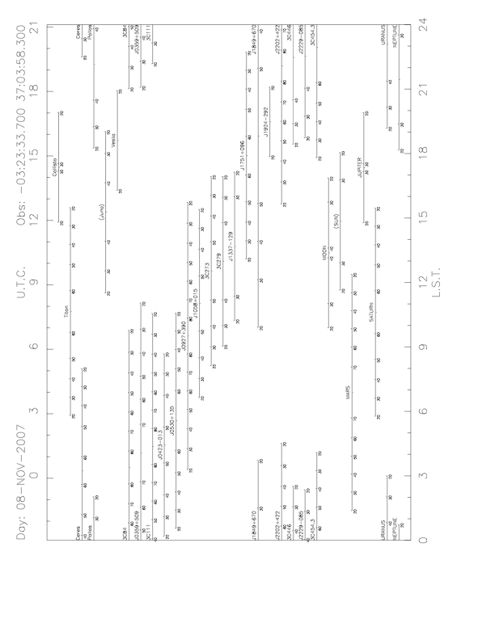

Appendix F: Availability of selected astronomical sources
The following plot shows the availability of selected sources. This plot is meant to illustrate the completeness of coverage of sources throughout the day, and is by no means a complete list of GISMO sources.

